A Rooster is a male chicken
A Hen is a female chicken
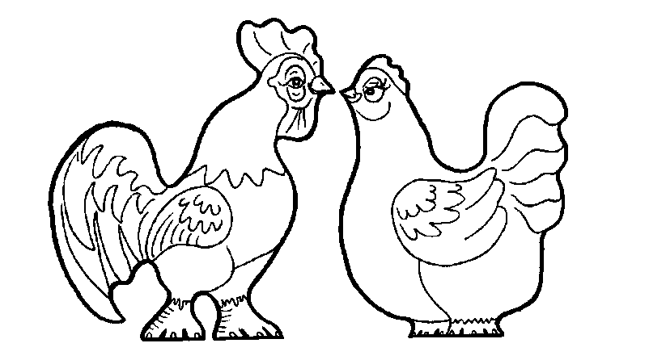
Which one is the Hen?

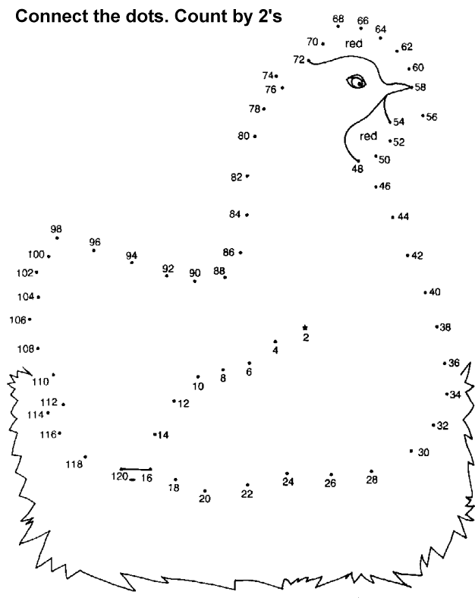

We have over 20 different kinds of chickens. They lay green, brown, and white eggs. Some of the eggs you buy at the store are washed, polished, and waxed. They are not as healthy as free-range farm raised eggs.

